**5/15/2021**

**I/ Binary Classification:**

**II/ Logistic Regression:**

**III/ Cost Function:**



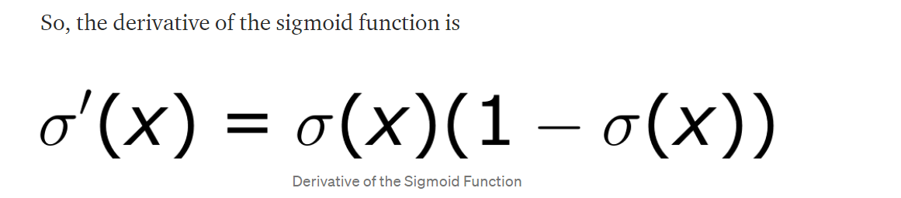

**IV/ Logistic Regression Derivatives – Gradient Descent for 1 training sample:**

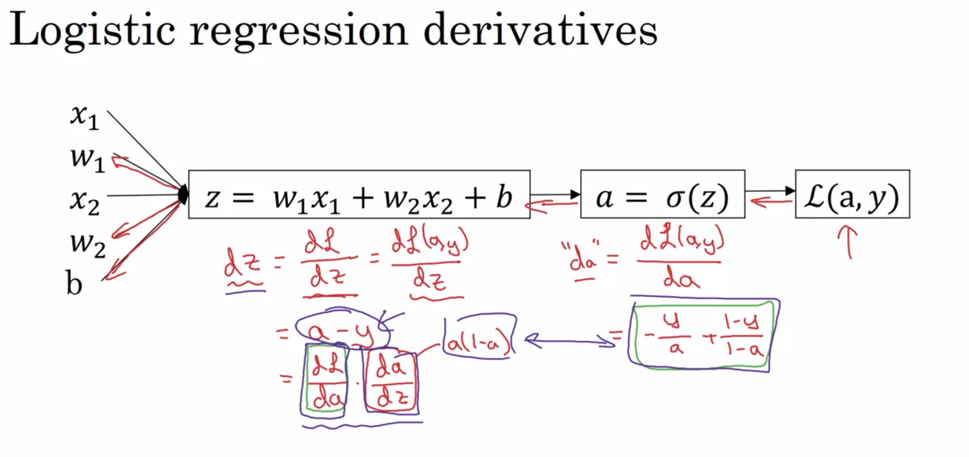

**V/ Gradient Descent for m training samples:**

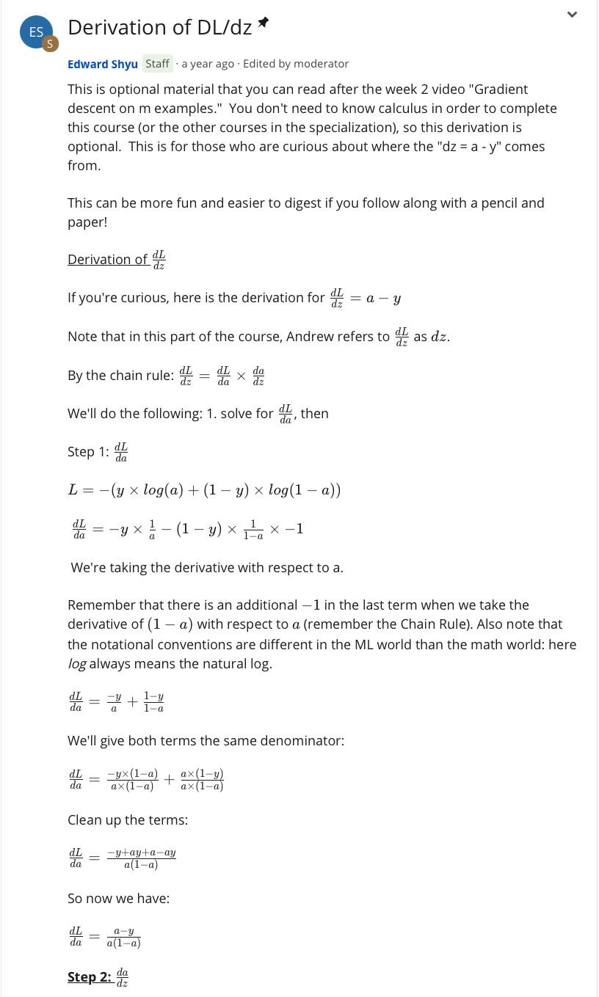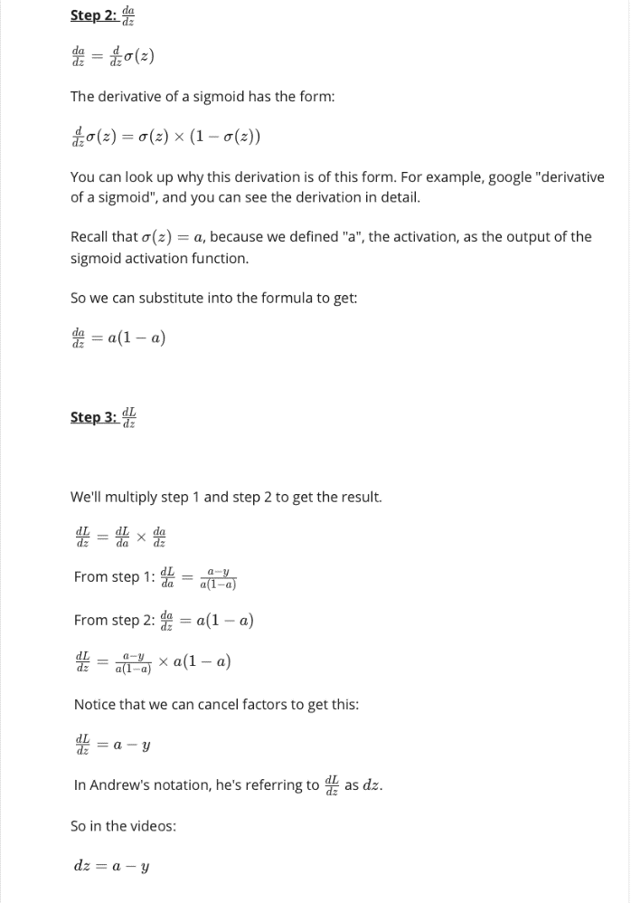

**IV/ Vectorization = art to get rid of for loop**

* Basically np.dot product
* Logistic Regression For Loop Equations – nonvectorized version:

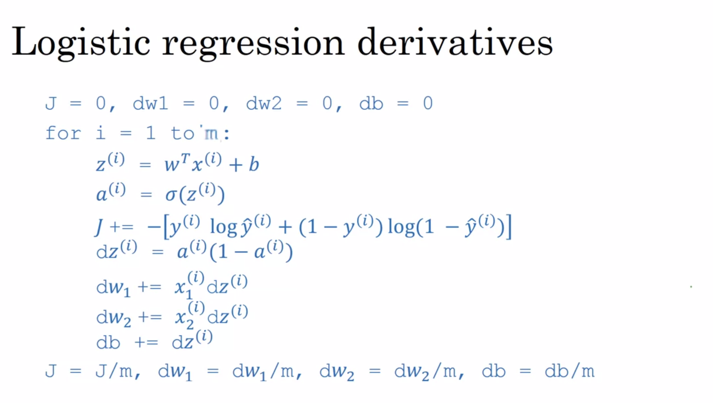

**V/ Vectorize Logistic Regression:**

**VI/ Vectorization Logistic Regression Gradient Calculation:**

* 